# Build a Minimum Viable Generative Art NFT Pipeline

## The proof of concept for a Platform — A step-by-step guide to creating a generative art NFT pipeline.

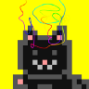

[BeautifoolData](https://medium.com/@beautifooldata?source=post_page-----292a12f433ef-----------------------------------)

[Follow](https://medium.com/m/signin?actionUrl=https%3A%2F%2Fmedium.com%2F_%2Fsubscribe%2Fuser%2Fa951333666b1%2F292a12f433ef&operation=register&redirect=https%3A%2F%2Fpython.plainenglish.io%2Fa-minimum-viable-generative-art-nft-pipeline-that-you-can-build-proof-of-concept-for-a-platform-292a12f433ef&user=BeautifoolData&userId=a951333666b1&source=post_page-a951333666b1----292a12f433ef---------------------follow_byline--------------)

[Dec 6, 2021](https://python.plainenglish.io/a-minimum-viable-generative-art-nft-pipeline-that-you-can-build-proof-of-concept-for-a-platform-292a12f433ef?source=post_page-----292a12f433ef-----------------------------------) · 10 min read

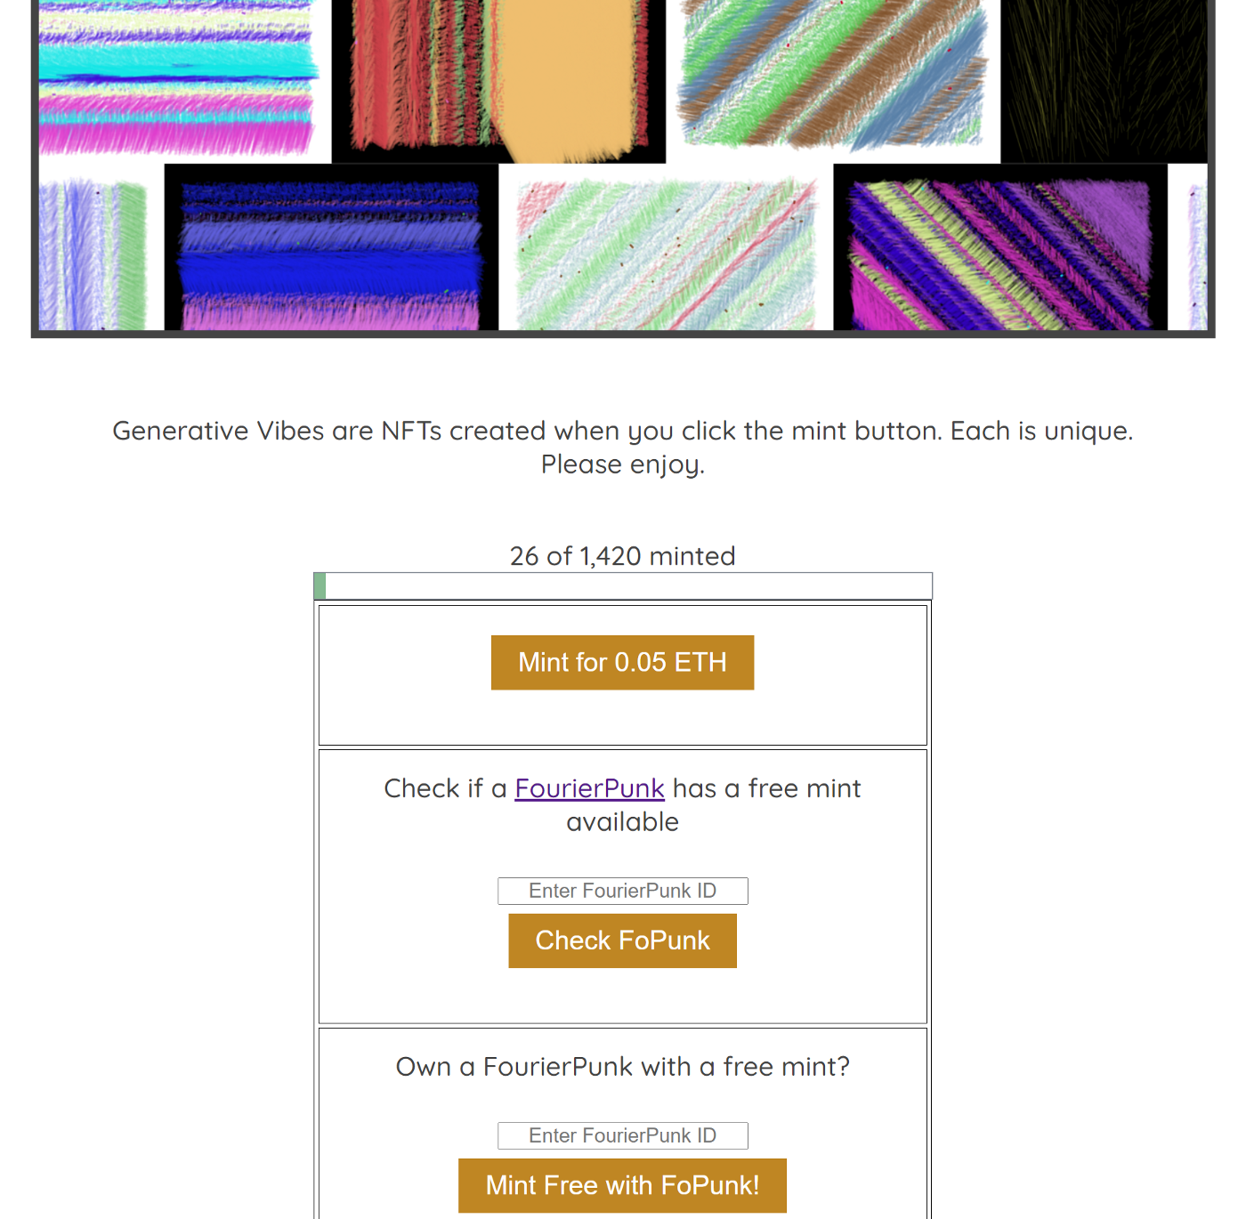

# Get up to speed

Here’s a great article on Medium if you have the time, a [111-minute read on what an NFT is](https://medium.com/coinmonks/nfts-101-why-nfts-are-a-generational-innovation-4626ae803e3b). Check out Wikipedia for a primer on [generative art](https://en.wikipedia.org/wiki/Generative_art).

For the sake of this article, I’ll assume you know a bit about NFTs, and you are thinking about making your own. We can say they are unique digital objects that represent proof of ownership of something. Generative art is art created by some amount of autonomous process.

NFTs are a great way to assign ownership to algorithmic art output.

# Current generative art platforms, and why you should build your own

Here are 4 platforms that are set to dominate the generative art space:

[ArtBlocks](https://artblocks.io/) — the number one platform for artists to create on-demand generative content stored on Ethereum

[DoodleLabs](https://www.doodlelabs.io/) — onboarding brands and real world artists, bridging the gap between the physical world and the NFT space

[fx(hash)](https://www.fxhash.xyz/) — an open platform to create generative NFTs on tezos

[gen.art](https://gen.art/) — membership based monthly art drops operating as a quasi-DAO with a central governance token

If you are an up-and-coming artist without a large following, it can be hard to get on to these popular, established platforms. At one point, ArtBlocks had months of artists on the backlog. They’ve closed their application process at the moment, so you will not be able to qualify for a Factory drop any time soon. Once you launch your platform, you release it on your schedule.

Another perk of doing it yourself is that you have full control over the details. You will be the featured artist at any point. I decided to set up free reserved mints tied to each of 420 [FourierPunks](https://www.fopunks.com/), a previous collection of mine. When you have control over the platform, you can get creative with distribution!

# On to the details, what did I try?

Below is an overview of the steps I took to create this pipeline, usable at [https://genvibes.io](https://genvibes.io/) while mints remain. I won’t claim that everything below is the right way to do things, but I’ve found that it works. I would love to hear feedback in the comments or on [Twitter](https://twitter.com/BeautifoolData) if you have any suggestions or questions!

***Step 1. Write your generative art code in a scripting language of choice***

I’ve seen a lot of great output from generative artists on [Twitter](https://twitter.com/search?q=p5js&src=typed_query&f=image) using p5js, so that is what I used for this project. In theory, you can use whatever scripting language you like. I’d say, the fewer dependencies, the better. Also, it would be optimal to produce the smallest size script possible in bytes. The reason being the script will end up in your contract, ideally.

So, write an awesome art creation script that relies on randomness bound by the same rules and produces varying but unified outputs, where each is beautiful and unique.

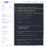

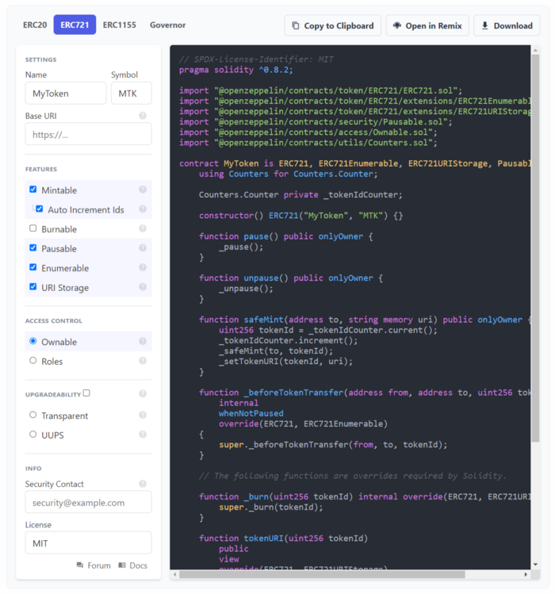

ERC721 Wizard from OpenZepplin

***Step 2. Create your solidity contract***

The contract is what ties together all the important aspects of ownership and provenance via a token. For most projects, I fire up the online [Remix](https://remix.ethereum.org/) IDE and bootstrap a contract using the [OpenZepplin wizard](https://docs.openzeppelin.com/contracts/4.x/wizard) for ERC721 contract libraries.

There are a few functions that I added at this point to prepare for the pipeline. I’ll use snippets from the [Generative Vibes contract](https://etherscan.io/address/0xaAFEf5aF4906FC7901aAFfC82dDB9dB45f3983Ed) as examples. We’ll start with the mint function.



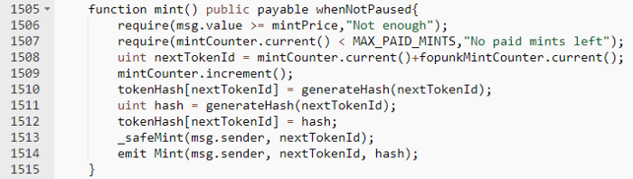

This mint function requires payment and limits the total number of mints. It keeps track of the token ID using the OpenZepplin Counter object. For many other NFT projects, the token ID would increment and get sent to the minter. But for this pipeline, I wanted to include a mapping of token ID to a random hash generated upon mint.





Generate the seed for randomness

The code for the random number generation uses the 20 rightmost digits of the keccak256 hash of attributes about the block, the token id, and the minter. This value is used to seed the code from step 1 and determines the art output received. Make sure to test your seeds! I noticed that p5js started creating similar output when seeds were close to each other, or when they exceeded a certain value. Test your seeds.



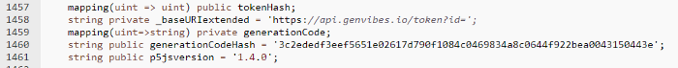

Stored values to make this more on-chain

A few state variables are used to get this to a higher level of on-chainyness.

* tokenHash maps tokenId to its random number
* p5jsversion stores the version of the script’s only dependency
* generationCodeHash is the keccak256 hash of the JavaScript code
* _baseURIextended is the metadata endpoint
* generationCode is a mapping of an index to a string, intended to store the generation in chunks on the contract

The goal is to set up the contract to have a final state where the contents of the contract alone can recreate the art. I recommended fewer dependencies earlier because they’re more costly to get on chain. The minified version of p5js is nearly 800kb and that would amount to about 512,000,000 gas. Given current gas costs, it could be more than 50 ETH. In the community, it seems like p5js is generally accepted as ‘obtainable from many sources and is unlikely to get lost’, so storing the version number should be sufficient for a very long time.

As stated, it’s pricey to store things on chain. So when deploying the contract, generationCode was included as a destination for the pieces of code. If someone wants to pull down the code, there is a get method to retrieve the strings by index. The script’s hash was hardcoded in during deployment for a later proof of “this is the code used to create your artworks.”



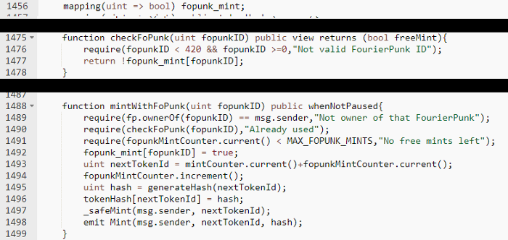

Reward supporters with free mints

The last few functions I decided to include allowed me to reward owners of a previous project. There is a separate mint function that allows a user to submit a FourierPunk ID, and if they verifiably own that token, their mint is free. I thought this would be a fun way to reward supporters from my previous project.

***Step 3. Create your minting website***

Given how savvy people are getting, you may not need one of these! A Twitter presence or Discord with clear instructions on how to mint from the [contract on Etherscan](https://etherscan.io/address/0xaAFEf5aF4906FC7901aAFfC82dDB9dB45f3983Ed#writeContract) could suffice.

But, here’s what I used: simple HTML, CSS, and vanilla JavaScript. Three buttons for minting, and a few links to socials. I used the [ethers.js](https://docs.ethers.io/v5/) library to interact with all things web3 — minting, checking for ownership, getting some counts, and listening for events. The site also has a [metadata API](https://api.genvibes.io/token?id=0) that returns an [OpenSea friendly](https://docs.opensea.io/docs/metadata-standards) JSON.



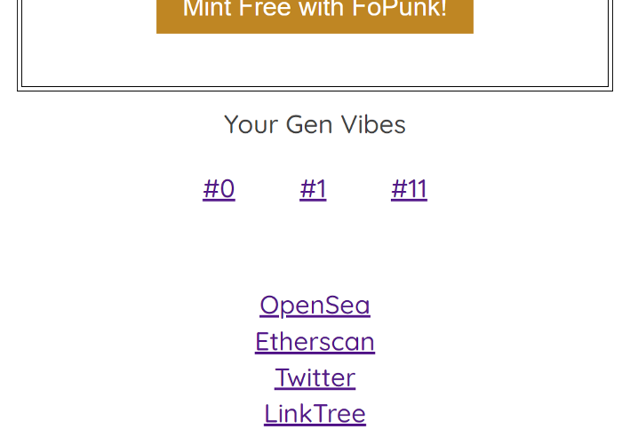

If a user comes to the site and they own some Generative Vibes, their token IDs will show at the bottom of the page. These links head to a view.html page which passes the ID as a parameter in the URL.

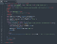

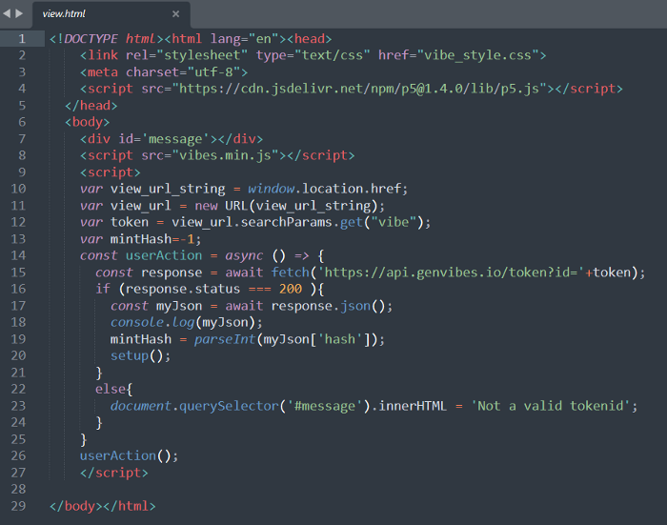

view.html renders the art using the minted token’s generated random number

The view page is what runs the JavaScript on the client-side. The page first imports our specific version of p5js from a CDN then injects the art generation script. The additional in-line JavaScript retrieves the seed from our API. This was a spot where I was mulling over what to do. I could have used web3 to call the contract and get the random number directly. To make the pipeline easier, I decided on the REST call rather than the web3 reliance.

***Step 4. Get your pipeline in place***

While I was conceptualizing this project, everything up to this point was pretty clear. I had been tinkering around in p5js finding ways to make pleasing outputs, and I already had an understanding of what the contract and website would be like because of experience in past projects. The questions that kept coming up for me were, “How do I go from mint to hosted image that script generated? What kind of infrastructure do I need? How do I make it resilient and speedy? Is there a risk of the code rendering differently based on different environments? Do I need to sit myself down and learn Kubernetes/Docker and host this? What is this all going to cost?”

Analysis paralysis. Until. 🎇💡 🎇 “*Just do it all locally.*” A simple solution, maybe foolish? Didn’t matter, got me moving again. So I got myself in front of my favorite IDE, Jupyter, and commented in a pipeline. The path became clearer.



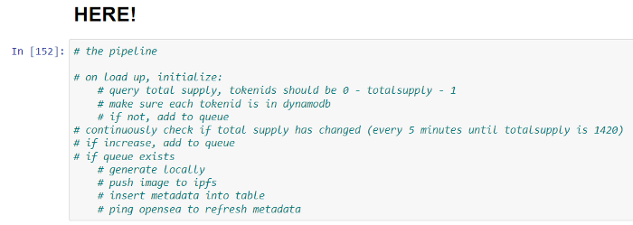

At this volume, there’s no issue doing this from my own machine 💡

Here comes the pipeline code.



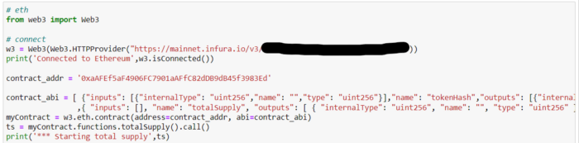

Pipeline #1 — web3

First, check the total supply of the contract.



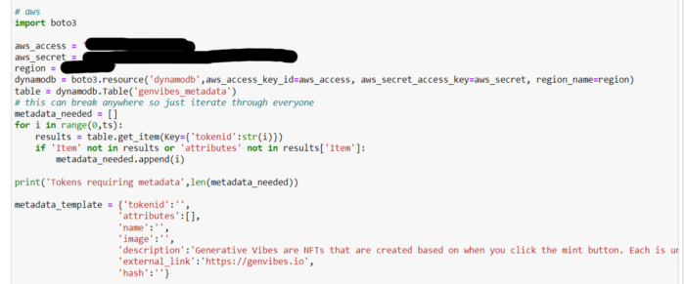

Pipeline #2 — the metadata check

Second, iterate through each token and check if they have metadata associated. If not, add the token ID to a queue. For this pipeline, missing metadata means that the token is newly minted and the art is not rendered and hosted.

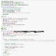

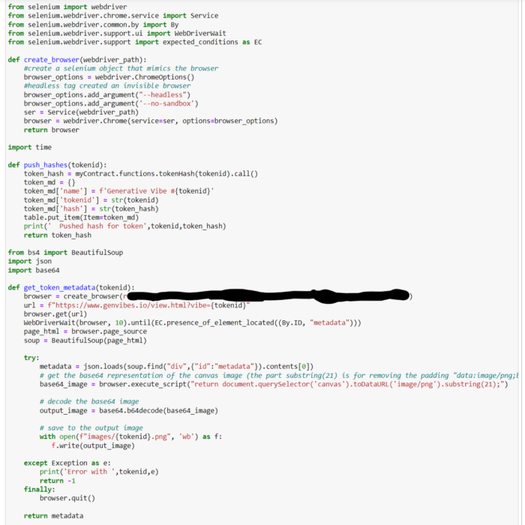

Pipeline #3a — supporting functions

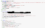

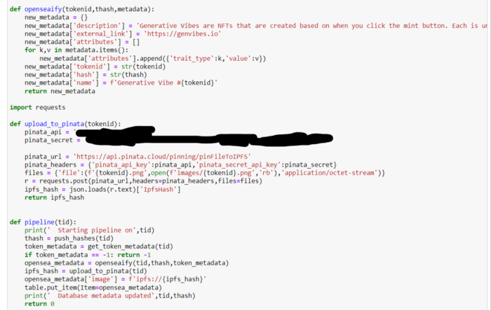

Pipeline #3b — supporting function

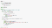

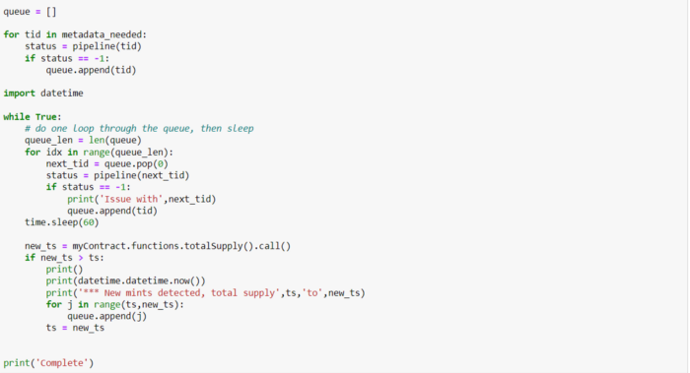

Pipeline final — the listening loop

The way this is coded — horrendous. Mid code imports, redundancies, sub-par optimizations. 😱 But does it work? So far, yes. Moving past that…

Starting with the last image, we can see that the queue we built up in the previous step is now iterated through. Each token id is passed into the pipeline function. The first portion of metadata is pushed to an AWS DynamoDB to feed the API. At this point, when you go to [https://api.genvibes.io/token?id=](https://api.genvibes.io/token?id=0){tid} , you will get a token ID and its random number back.

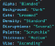

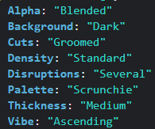

Metadata from the generated p5js art

The next part saves the png and the attributes of that token’s art. I had things working well, so I didn’t want to make many more script changes. For this part, I used Selenium to fire up a browser and load the token’s art which simulates when someone navigates to it. The metadata values are returned from a function in the p5js script, which is placed in a <div> that can be scraped by BeautifulSoup. The image is saved to my desktop.



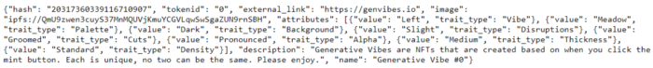

OpenSea friendly metadata

openseaify() then constructs the metadata in a way that fits the OpenSea metadata standards. Everything is ready except the image, which needs to be hosted somewhere. I use some endpoints from the [Pinata](https://www.pinata.cloud/) pinning service to upload the saved png to IPFS. This returns the IPFS hash which can be stored in the JSON and is usable by OpenSea. Once the metadata is finalized, we update the record in DynamoDB.

***Step 5. Run it!***

With all the components created, put everything where they need to go! Here is a review of the architecture that I used:

✅ AWS Amplify for website

✅ AWS DynamoDB for metadata storage

✅ AWS API Gateway for the REST endpoint

✅ Dedicated machine for rendering pipeline

Then it is off to Twitter and Discord to promote 👈 (*the hard part*)

# Room for improvement

There’s a glaring fault with my current setup. The rendering pipeline needs to keep running until the project mint is finished. At this point, there have been about 20 mints in a few days, and with a cap of over 1000 max supply, it looks like it could be a while. I will be looking into getting the pipeline onto a cloud server.

The next issue is the time it would take to render a large queue. Luckily, this script creates its output in a few seconds. Even if the remaining tokens get minted in the next block, it would complete in a few hours. Not a terrible spot to be in. If I were trying to improve this, I would look into a proper queuing technology like Kafka, and allow this to scale wide. There's nothing in the process right now that would restrict that.

Finally, as a variation, I’ve seen other platforms spawn multiple projects from the same contract using patterned token IDs, whereas my example here is for a single collection. I haven’t thought about the pros and cons of doing such a thing.

If you can think through those issues above and put together some good art, you have a pretty proper platform! That’s all I have for you from this project. Did you find any parts useful? Any suggestions on how to do things better? Let me know!

If you enjoyed this article, please reach out on [Twitter](https://twitter.com/BeautifoolData) and check out [Generative Vibes](https://genvibes.io/)

Please enjoy.

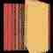



Generative Vibes minted so far…

*More content at* [*plainenglish.io*](http://plainenglish.io/)*. Sign up for our* [*free weekly newsletter here*](http://newsletter.plainenglish.io/)*.*